***UCF SENIOR DESIGN 1***

***Title***

*Portable Unit for Sanitation of Waterborne Pathogens through UV light*

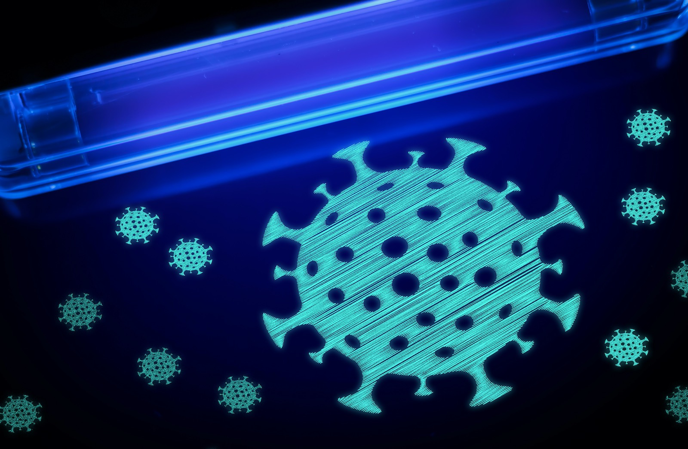

***Group Number 4***

***Group Members:***

Joseph Wahlen - Photonic Engineering

Raymond Masciarella - Photonic Engineering

Damian LaRocque - Electrical Engineering

Sannidiyan Rajendran - Computer Engineering

No current customers, sponsors, or significant contributors

***Motivation***

The recent coronavirus epidemic has made many of us hyper aware of the risks unseen pathogens pose to our health. Day to day many of us take for granted the high quality of water we have access to. This project was inspired by the need to take these pathogens seriously and is focused on a method to clean water with UV radiation in places where clean water isn't readily available.

The method involves pumping water from a fill tank to a processing tank where UV radiation illuminates the water. The lightsource is a UV-C flashlamp. The light is dispersed through the water evenly through a system of lenses and mirrors that spread the optical intensity to ensure that all of the water is being cleaned. The water is then further pumped into a 3rd tank for analysis. This analysis tank will make use of one of two spectroscopy techniques, Raman scattering and hyper spectral imaging. Information about the quality of the water from analysis is then reported to the user through a LCD user-interface integrated into the tank. The whole system is designed to be simple to use, low cost, portable and not require any expert knowledge to interpret the results of analysis. An example of the design can be shown in Figure 1 and 2 which show an illustration of a prototype design.

The system will be powered by solar power and a battery. Using solar power reduces energy costs to power the system but requires direct sunlight. In the case where direct sunlight isn’t accessible a backup battery is available to power the pump, lamp, and electronics necessary to operate the device. Each tank will require some individual sensors to avoid overfilling and will have automated pumping based on the readings of the sensors.

The goal of the project, as stated above, is to develop a system utilizing UV light for the sanitation of water. Leveraging prior technology like water filters, UV lamps, and UI Design to create a simple, easy to use system. The system will be created to be used in multiple situations to yield clean, usable water omitting pathogens and other potentially harmful substances.

***Project Requirements and Specifications***

* Solar powered
  + Be able to run at least 1 cleaning cycle with no additional power sources
* 2 Water standards
  + Meet SDWA standard that dictates a level of zero coliform per 100 ml of water to designate it as potable
* Efficient processing
  + Clean up to 5 gallons of water for use
  + Should take less than 30 minutes to become ready for use from time of input
  + Be able to vary the power based on the available amount of battery and ambient light
* LCD User interface
  + Controlled by a Raspberry Pi 4
  + Integrated with spectrometer and other electronics
  + Display useful information about the state of the system and quality of water
* UV-C lightsource
  + Guided by geometric optics, lens and mirrors
  + Evenly distributed field of light
* Ambient Sunlight source
  + Guided by geometric optics the unit will take ambient sunlight, focus it into the chamber, and scan the light across the tank.

***Project Block Diagrams and Illustration***

Diagram of Portable UV system

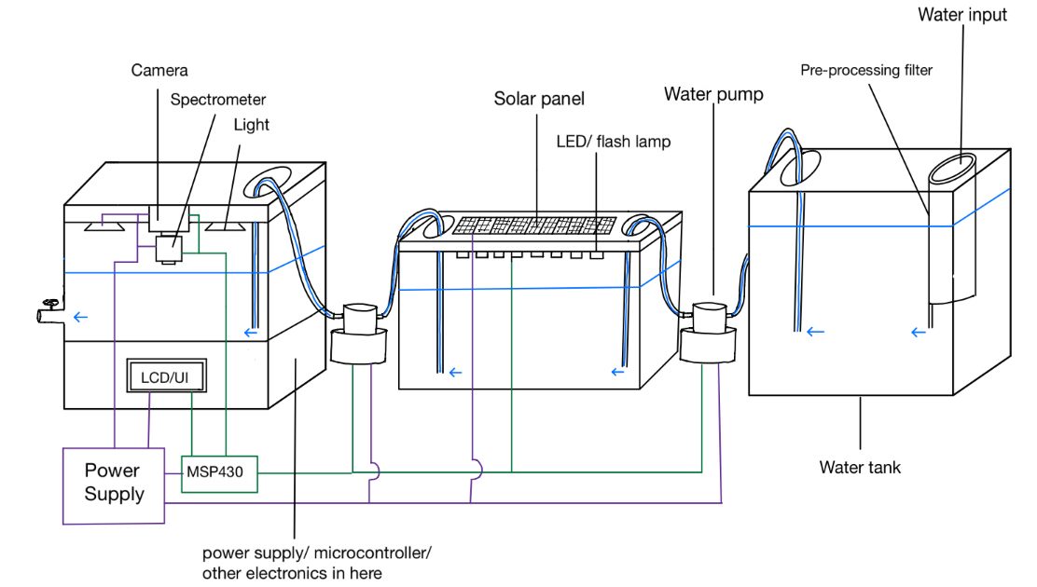

*Figure 1: Illustration of 3 tank system and connections*

Diagram of full system in a more compact design

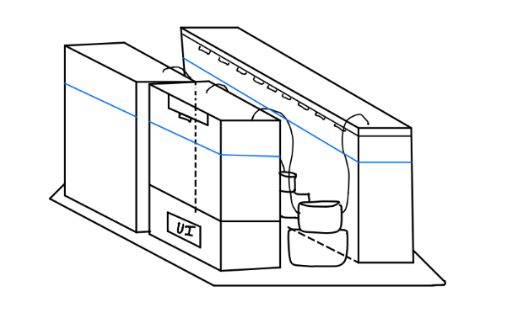

*Figure 2: Illustration of initial layout idea*

***Block Diagram for UV water system***

*Figure 3: Block diagram detailing the plan* 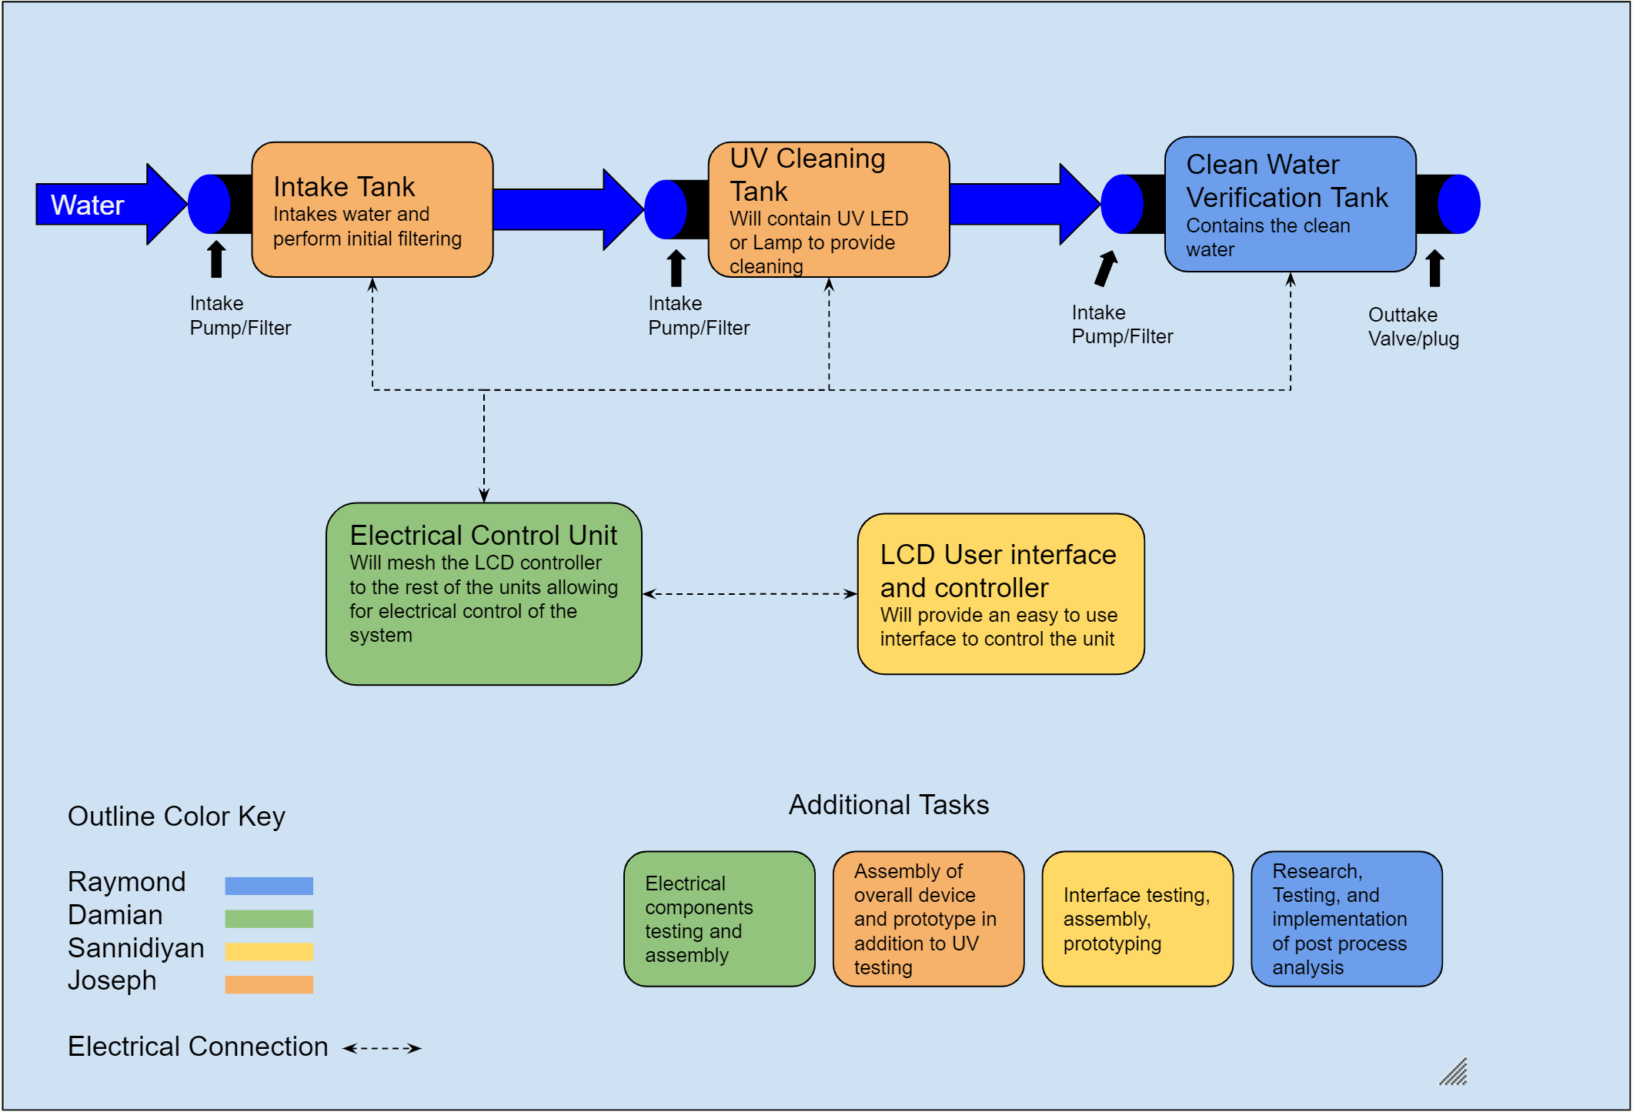

***Budget and financing***

|  |  |  |  |  |
| --- | --- | --- | --- | --- |
| **Item** | **Vendor** | **Price Per Unit** | **Quantity** | **Total Price** |
| UV LED | TBA | ≈$20.00 | 4+ | $0.00 |
| Flash Lamp | TBA | ≈$35.00 | TBD | $0.00 |
| Angled Mirror | TBA | TBD | TBD | $0.00 |
| Raspberry Pi 4 | Adafruit | $35.00 | 1 | $35.00 |
| Acrylic water tank | TBA | TBD | TBD | $0.00 |
| Water Pump | TBA | TBD | TBD | $0.00 |
| Solar Panel | TBA | ≈$60.00+ | TBD | $0.00 |
| Spectrometer source | TBA | TBD | TBD | $0.00 |
| Pre-Processing Filter | TBA | ≈20-50.00 | TBD | $0.00 |
| LCD for UI | Longrunner | $55.00 | 1 | $55.00 |
| Camera | Jun-Electron | $30.00 | 1 | $30.00 |
| Water Level Sensor | TBA | TBD | TBD | $0.00 |

*Table 1: Budget and Financing chart detailing expected costs for the project*

***Milestones***

|  |  |  |  |  |  |
| --- | --- | --- | --- | --- | --- |
| **Number** | **Task** | **Start** | **End** | **Status** | **Responsible** |
| **Senior Design I** | |  |  |  |  |
| 1 | Ideas and Group Formation | 5/11/2020 | 5/15/2020 | Completed | Group |
| 2 | Project Selection & Role Assignments | 5/11/2020 | 5/15/2020 | Completed | Group |
|  | **Project Report** |  |  |  |  |
| 3 | Initial Documentation - Divide and Conquer | 5/18/2020 | 5/29/2020 | Completed | Group |
| 4 | Divide and Conquer V2 | 6/1/2020 | 6/5/2020 | In Progress | Group |
| 5 | 60-page Report | 6/5/2020 | 7/3/2020 | In Progress | Group |
| 6 | 100-page Report | 7/3/2020 | 7/17/2020 | In Progress | Group |
| 7 | Final Documentation | 7/17/2020 | 7/28/2020 | In Progress | Group |
|  | **Research and Design** |  |  |  |  |
| 8 | UV Cleaning Research | 5/15/2020 | 5/29/2020 | In Progress | Joe |
| 9 | Spectroscopy Research | 5/15/2020 | 5/29/2020 | In Progress | Raymond |
| 10 | Design Specifications | 5/25/2020 | 7/1/2020 | In Progress | Group |
| 11 | Design of Cleaning System | 5/25/2020 | 6/15/2020 | In Progress | Group |
| 12 | Design of User Interface | 5/25/2020 | 6/15/2020 | In Progress | Nidiyan |
| 13 | Design of Electronics | 5/25/2020 | 6/15/2020 | In Progress | Damian |
| **Senior Design II** | |  |  |  |  |
| 14 | Building of Prototype | 8/24/2020 | 12/1/2020 | Not Started | Group |
| 15 | Testing and Redesign | TBA | TBA | Not Started | Group |
| 16 | Final Prototype | TBA | TBA | Not Started | Group |
| 17 | Peer Presentation | TBA | TBA | Not Started | Group |
| 18 | Final Documentation | TBA | TBA | Not Started | Group |
| 19 | Final Presentation | TBA | TBA | Not Started | Group |

*Table 2: Projected timelines for goals of the project*

***Engineering Trade Off Matrix***

|  |  |  |  |  |  |  |  |  |
| --- | --- | --- | --- | --- | --- | --- | --- | --- |
| ***Engineering Requirements →*** |  | ***Efficiency*** | ***Output Power*** | ***Implementation time*** | ***Weight*** | ***Cost*** | ***Dimensions*** | ***Solar Charge Time*** |
| ***Engineering Targets*** |  | ***TBD*** | ***TBD*** | ***<30 minutes*** | ***<50 pounds*** | ***<500$*** | ***Fits in 4X4 foot area*** | ***<6 hours*** |
|  |  | ***+*** | ***+*** | ***-*** | ***-*** | ***-*** | ***-*** | ***+*** |
| ***Market***  ***Requirements ↓*** |  |  |  |  |  |  |  |  |
| ***Low Cost*** | ***+*** | ***↑*** | ***↓↓*** | ***↑*** | ***↑*** | ***↑↑*** | ***↑*** | ***-*** |
| ***Portability*** | ***+*** | ***↓*** | ***↓↓*** | ***↓*** | ***↑↑*** | ***↓↓*** | ***↑↑*** | ***↑*** |
| ***Kills Pathogens*** | ***+*** | ***↑*** | ***↑↑*** | ***↑*** | ***-*** | ***↓↓*** | ***-*** | ***-*** |
| ***Ease of Use*** | ***+*** | ***↑↑*** | ***-*** | ***↓*** | ***↑*** | ***↓↓*** | ***↑*** | ***↓*** |
| ***Capable of multiple power modes*** | ***+*** | ***↑↑*** | ***↑↑*** | ***↑*** | ***-*** | ***↓↓*** | ***-*** | ***↑↑*** |
| ***Durable*** | ***+*** | ***↑*** | ***-*** | ***-*** | ***↑*** | ***↓*** | ***↑*** | ***↑*** |
| ***Modular*** | ***+*** | ***↑*** | ***↑*** | ***↑*** | ***↑*** | ***↓*** | ***↑↑*** | ***↑↑*** |

*Table 3: Table detailing the trade of matrix of various project engineering solutions.*

***Legend For Trade off Matrix:***

* ***+ : Positive Polarity***
* ***- : Negative Polarity***
* ***↑ : Positive Correlation***
* ***↑↑ : Strong Positive Correlation***
* ***↓ : Negative Correlation***
* ***↓↓ : Strong Negative Correlation***
* ***- : No correlation***

***Conclusion***

In conclusion our project aims to offer a novel and portable solution for sanitation of drinking water using a combination of filtering, UV light and ambient solar light. The device will employ several pumps, chambers, and filters to move the water from a dirty source into the cleaning tank and then finally to a holding tank for use. The water will be either pumped or placed into the initial holding cell, filtered into the cleaning tank, irradiated with a large amount of evenly distributed UV light for at least 20 minutes, and then moved to a cleaning tank for use. In case there is no readily available power supply the unit will be able to run in a lower power mode powered by solar panels and batteries. The cleaning in this low power stage will be assisted by harnessing the natural light of the sun and focusing its UV rays onto the tank for additional sanitary effects.

***Citations and Research Articles***

1. ***Buonanno, M., Ponnaiya, B., Welch, D., Stanislauskas, M., Randers-Pehrson, G., Smilenov, L., … Brenner, D. J. (2017). Germicidal Efficacy and Mammalian Skin Safety of 222-nm Uv light. Radiation Research Society.***
2. ***Guo, S., Huang, R., & Chen, H. (2017). Application of water-assisted Uv light in combination of chlorine and hydrogen peroxide to inactive Salmonella on fresh produce. International Journal of Food Microbiology***
3. ***.Kim, C., Eom, J. B., Jung, S., & Ji, T. (2015). Detection of Organic Compounds in Water by on Optical Absorbance Method. MDPI.***
4. ***Moguilnaya, T., & Sheryshev, A. (n.d.). Optical Express Methods of Monitoring of Pathogens in Drinking Water and Water-Based Solutions. IntechOpen.***
5. ***Utkin, A. B., Lavrov, A., Vilar, R., & Babichenko, S. M. (2011). Optical Methods for Water Pollution Monitoring. ResearchGate.***
6. ***Yerby, E. (n.d.). Apparatus and Method for Sanitizing Articles Utilizing a Plurality of Reflector units to evenly distribute the Uv radiation. United States Patent.***
7. ***Zhang, S., Ye, C., Lin, H., Lv, L., & Yu, X. (n.d.). Uv Disinfection Induces a Vbnc State in Escherichia coli and Pseudomonas aeruginosa. Environmental Science & Technology.***